Learning activity 2 / Actividad de aprendizaje 2
Evidence: Personal likes / Evidencia: Gustos personales

I'm dickson I'm 30 years old I live in a small apartment with Emely. I love animals, especially big dogs.

Emely does not like animals.

I had a German shepherd.
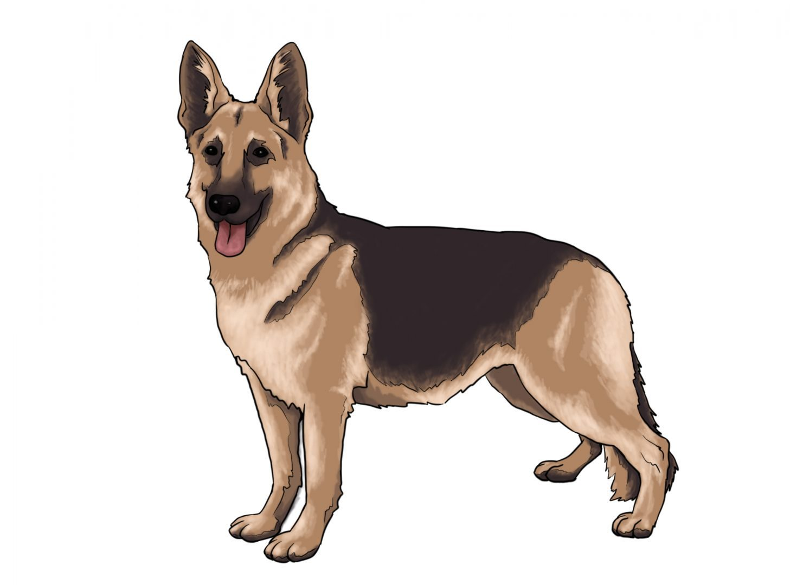Su nombre era Luca.

On weekends I play ping-pong about 2 hours with my friends. 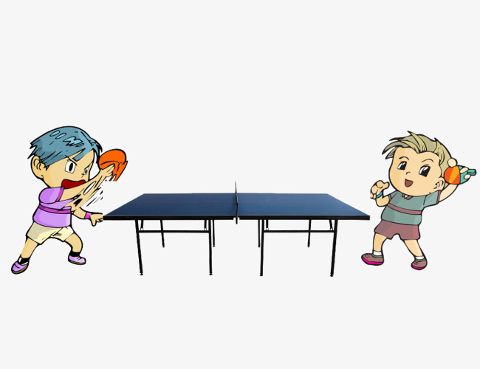
I also like horses.
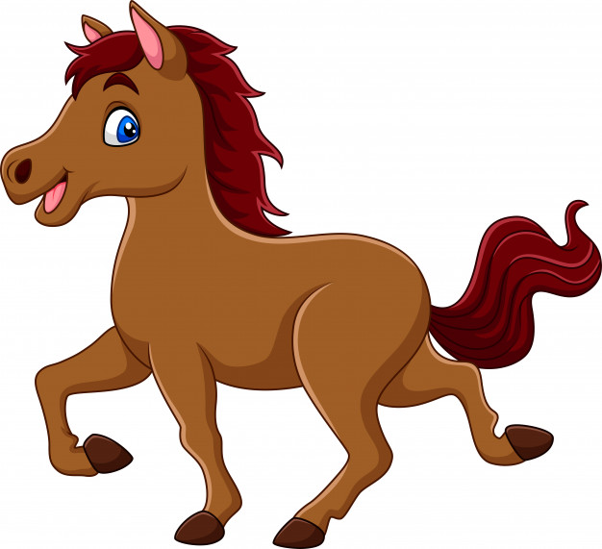

My favorite wild animal are the lions because they are big and strong.


I practice few sports. But I love football.
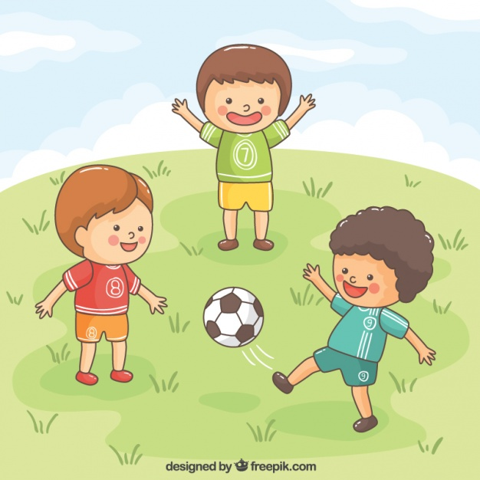
I usually play with my friends in the sports unit Maria Luisa Calle.

